IdeationPhase

Brainstorm&IdeaPrioritizationTemplate

|  |  |
| --- | --- |
| Date | 24july2025 |
| TeamID | PNT2025TMID09231 |
| ProjectName | VisualizingHousingMarketTrends:AnAnalysis of Sale Prices and Features using Tableau |
| MaximumMarks | 4Marks |

# Brainstorm&IdeaPrioritizationTemplate:

Brainstormingprovidesafreeandopenenvironmentthatencourageseveryonewithinateam to participate in the creative thinking process that leads to problem solving. Prioritizing volumeovervalue,out-of-the-boxideasarewelcomeandbuiltupon,andallparticipantsare encouraged to collaborate, helping each other develop a rich amount of creative solutions.

Use this template in your own brainstorming sessions so your team can unleash their imagination and start shaping concepts even if you're not sitting in the same room.

Reference:<https://www.mural.co/templates/brainstorm-and-idea-prioritization>

# Step-1:TeamGathering,CollaborationandSelecttheProblemStatement

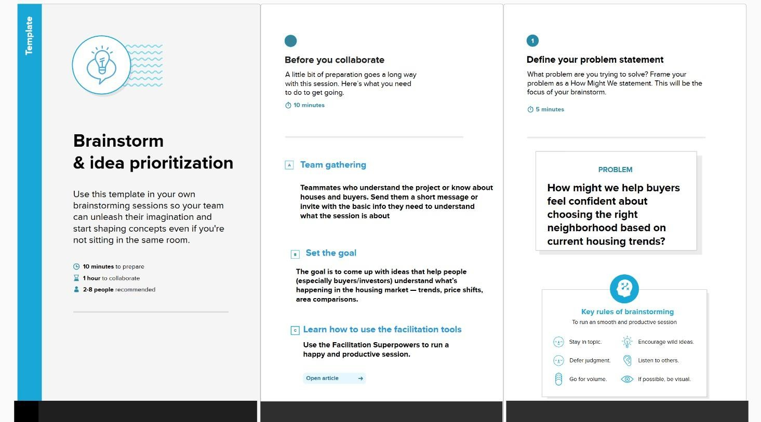

**Step-2:Brainstorm,IdeaListingandGrouping**

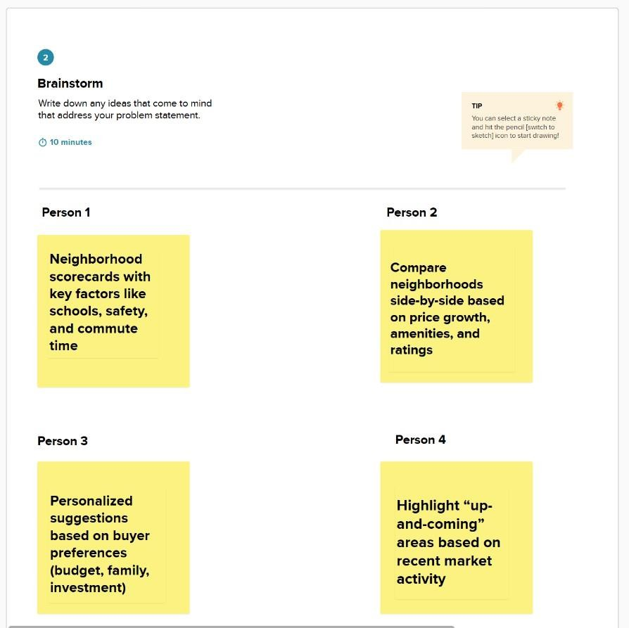

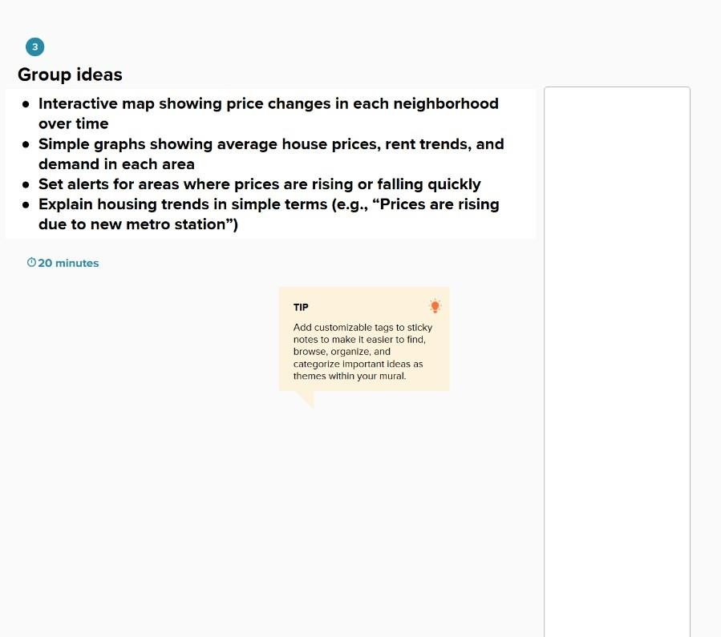

**Step-3:IdeaPrioritization**

